Your Mission: The Grandparents' Helper
The Problem in a Story (10 mins): "Now, let's meet our character, Dadi. She's a wonderful grandmother who lives by herself in India. Her children live very far away, and they call her every day to check in. Dadi loves to take care of her beautiful garden and tell stories to her friends. But lately, a small problem has started to become a big challenge for her."
"Dadi needs to take a few medicines every day to stay healthy. But the bottles have tiny, tiny words on them, and sometimes the words are in a language she can't read. Her eyes aren't as young as they used to be, and it's difficult for her to read the name of the medicine or check the expiry date. She also sometimes forgets to take them at the right time, especially when she is busy with her favorite TV show or phone calls."
"This is our mission, Tech Detectives! We need to find a way to help Dadi, and all the other grandparents like her, manage their medicines. How can we use technology to make their lives easier and safer?"

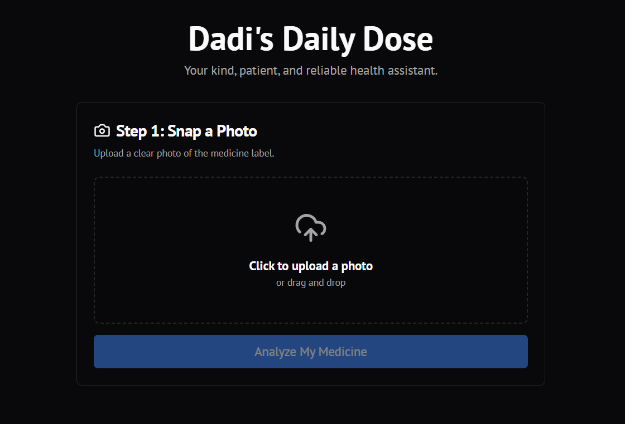
We saw how hard it is for grandparents like Dadi to read the tiny, complicated words on medicine bottles. Your mission is to use vibe coding to program the Smart Brain (AI) to be their kind, patient, and reliable daily health assistant.
The goal is to solve the problem of small text and forgetfulness using your imagination and the English language!

The Vibe Coding Prompt
When you use the tool, you are giving the Smart Brain a very specific instruction. Your goal is to tell it what to find in the image, and most importantly, how to talk to the user.
Use the following ideas to guide your creation:
 Input to the App | A clear photo of a medicine strip or bottle label.
 The Smart Brain Instruction (Your Prompt) | "Look at this medicine label. I need you to act as a kind, gentle friend with a clear, steady voice, helping an elderly person with poor eyesight. Please perform three tasks, using only very simple, large-print sentences."
 | Task 1: Identify and Explain - What is the name of this medicine? Tell me simply what it helps with (e.g., This helps with your blood pressure.).
 | Task 2: Check Safety - What is the expiry date? Give a clear warning if the date is close or passed.
 | Task 3: Suggest Timing - Based on this medicine type, what is the best time of day to take it (e.g., Take this after breakfast).
 Crucial Output | The final response must be turned into a clear, reassuring audio message that the grandparent can listen to.

